Tallinna 6. joonistustriennaal / 6th Tallinn Drawing Triennial
IMPULSS / IMPULSE

09.07.—01.08.2021. ARS. Tallinn. Estonia

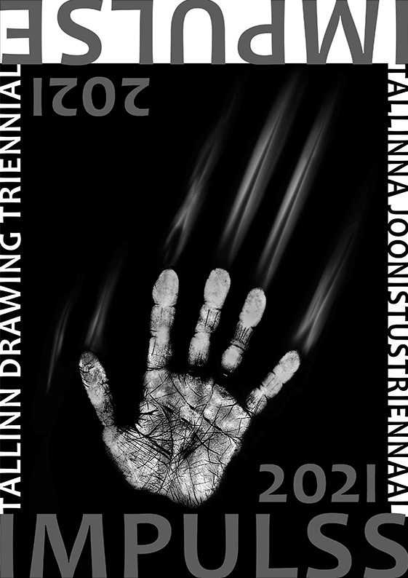
Application form

Last name:
First name:
Date of birth:
Institution :
Postal address:
Postal code, city, country:
Phone:
E-mail:
Other relevant data:

Agreement for printing your e-mail address on the participants list: ___ Yes  ___ No 

-------------------------------------------------------------------------------------------------------------------------------------------------------------------------
Title Year Dimensions (height x width) Material, medium
1.
2.
Additional information, education, recent exhibitions:

Date: Signature:

Tallinna 6. Joonistustriennaal
IMPULSS / IMPULSE
Tallinn 6th Drawing Triennial

Contact: Loit Jõekalda
E-mail: loit.joekalda@gmail.com

Address: Graafikakoda,
Association of Estonian Printmakers,
Vabaduse väljak 6, 10146 Tallinn, Estonia
Phone: +372 5569 6086

